UNC - DWD
Draft Requirements and Specification Document (Task 2.6.1)
Software Requirements Specification

Version 1.0

Document Change Record
Version Number | Date | Description
1.0 | 2/23/2005 | Initial document
1.1 | 3/23/2005 | Added Introduction
1.2 | 3/28/2005 | Project Description
1.3 | 4/1/2005 | Requirements
1.4 | 4/6/2005 | System Architecture and Appendix
1.5 | 4/27/2005 | Components 5.1
1.6 | 5/5/2005 | Components 5.2 & 5.3
1.7 | 5/12/2005 | Revised System Architecture
1.8 | 5/16/2005 | Added in web service
1.9 | 5/25/2005 | Instituted changes in response to reviews, and finished web service component

TABLE OF CONTENTS

1. Introduction 1
1.1 Scope 1
1.1.1 Identification 2
1.1.2 System Overview 2
1.1.3 Document Overview 3
1.2 Reference Documents 3
2. Project Description 5
2.1 Project Perspective 5
2.2 Project Functions 5
2.3 User Characteristics 5
2.4 Constraints 5
2.5 Qualification Provisions 5
2.6 Assumptions and Dependencies 6
3. Requirements 7
3.1 Java GUI for dwd adjustment 7
3.2 Matlab Code For DWD Conversion 7
3.3. java visualization 8
3.4 Web Service Version of DWD 8
4. System architecture 9
5. Components 13
5.1 Java GUI For DWD Adjustment 13
5.2 Matlab Code For DWD Conversion 17
Java Visualization 18
5.4 Web Service Version of DWD 22
6. Sign off 24
6.1 Approval 24
Appendix A – Acronym List 25

Introduction
This Software Requirements and Specifications (SRS) document captures the complete software requirements for the Distance Weighted Discrimination software for combining microarray data sets, release version 1.
UNC Lineberger Comprehensive Cancer Center (Lineberger) has performed research on the meta-analysis of different microarray data sets. All large microarray datasets contain systematic biases that are due to different sources of RNA, different batches of microarrays and especially different microarray platforms. To address this challenge, individuals at Lineberger have developed a tool called Distance Weighted Discrimination (DWD) that makes statistical corrections to reduce these biases. The approach is based on modern statistical discrimination methods and was shown to be better than Support Vector Machines and Singular Value Decomposition for the adjustment of systematic biases.
Many institutions maintain archives of microarray data; however, data sets coming from different institutions and different microarray platforms are largely not directly comparable. Implementation of DWD may allow the merging of datasets which would allow, for example, the evaluation of all breast tumor microarray experiments (which individually total 500-600 experiments across 6 labs) as a single dataset that contains many common clinical parameters. A larger dataset such as this will allow subset analysis that is currently not possible due to small sample sizes.
To date, the method has been developed, evaluated and applied by one research group at UNC Chapel Hill. The current implementation uses MatLab for statistical calculations (a substantial limitation, since Matlab is expensive and not open source, and thus is unable to meet the caBIG™ licensing requirements). For this project, DWD will 1) Be deployed to the Adopter site(s) for analysis; 2) Be adapted to the caBIG architecture, particular through providing a web service for merging data sets; 3) Read in (and output) data either in Stanford Text Format, or in MAGE-ML; and 4) Be enhanced with visual diagnostics, to improve usability.

Scope
Distance Weighted Discrimination (DWD) can perform systematic bias adjustment in microarray data (http://genome.med.unc.edu:8080/caBIG/DWDindex.htm). The original version of DWD (called version 0.1 in this document) was written in Matlab, which requires the installation of that expensive software package. In Matlab, the BatchAdjustSM.m file is executed and the adjusted, combined data are written to a file. But BatchAdjustSM.m only takes a file that is combined from two separated files based on the common keys (genes). The centered output file from BatchAdjustSM.m will be processed again by putting back the keys. The pre- and post- processing work is done by two Perl scripts.
An important objective of this project is to convert the existing Matlab code into an executable that can be called by Java. All pre- and post- processing work, and the visual diagnostics, are also done in Java. The original Matlab version (0.1) of DWD is here called “Matlab DWD”, and the final product of this project will be a Matlab independent version of DWD, called “Java DWD (version 1.0)”.
There are four main parts of the programming components of this project:
- Design Java GUI for entering all input and output parameters.
- Convert the existing DWD Matlab programs for adjustment into c executable programs.
- Implement Java visualization, including Java GUI, Java principal component analysis (PCA), and the conversion of the Matlab code for kernel density estimation, into c executables
- Create a web services version of DWD. This will expose DWD analytics, running on our server, to the web users.

Identification
DWD 0.1: The original Matlab version of DWD, that is web available at: https://genome.unc.edu/pubsup/dwd/
DWD 1.0 The Java (Matlab independent) version of DWD, which will be a Silver level compliant of the caBIG™ program.

System Overview
Distance Weighted Discrimination (DWD) can perform systematic bias adjustment in microarray data (http://genome.med.unc.edu:8080/caBIG/DWDindex.htm). Inputs are two microarray data files (currently Stanford text format, but MAGE-ML will also be implemented), with no missing values, and common gene identifiers. The gene identifiers can be any the approved list that the ICR Genome Annotation SIG has compiled (or may compile in the future). Access to these can be found at: http://cdebrowser.nci.nih.gov/CDEBrowser/ See Section 2.4 below for a detailed discussion of the constraints. Output is a single merged data file (in either Stanford Text or MAGE-ML format).
DWD has been very successful at merging disparate microarray data sets, even across platforms. However, there are some important points to keep in mind. First, when there are multiple biological subtypes present, they need to be represented in each of the two files to be merged. E.g. if one file contains all of one type,and the other file contains all of the other, DWD might eliminate important biological differences. If the data come from different platforms, then pre-transformation can be useful. E.g. for combining cDNA and Affymetrix data, it can be helpful to take the log of the Affymetrix data before inputting to DWD.
The original version of DWD for microarrray data combination was written in Matlab, by J. S. Marron. A key component was the Matlab implementation of DWD for general purpose discrimination (i.e. classification), written by M. J. Todd. This was based on the SDPT3 optimization package of Toh, Tutuncu, and Todd, see http://www.math.nus.edu.sg/~mattohkc/sdpt3.html.
All of this software is currently internet available for free use. The research of J. S. Marron was supported by Cornell University's College of Engineering Mary Upson Fund and NSF Grants DMS-9971649 and DMS-0308331. M. J. Todd was supported in part by NSF Grants DMS-9805602 and DMS-0209457 and ONR Grant N00014-02-1-0057. SDPT3 was supported in part by National University of Singapore, Singapore-MIT Alliance, NSF through grant DMS-9805602 and ONR through grant N00014-96-1-0050, and NSF through grant CCR-9875559.
The Matlab version of DWD for microarray bias adjustment is internet available at https://genome.unc.edu/pubsup/dwd/.

Document Overview
This SRS captures the complete software requirements for the Distance Weighted Discrimination software for combining microarray data sets, Release 1, as part of the Integrative Cancer Research Workspace of the caBIG™ program. Requirements and procedural instructions are included in the Standard Operating Procedures (SOPs).
All software will be completely open source, as outlined under the GNU General Public License. There are no additional security or privacy considerations.
The remaining SRS sections are organized as follows:
- Section 2. Project Description: Describes the general factors that affect the Distance Weighted Discrimination software for combining microarray data sets.
- Section 3. Requirements: Describes all the software requirements to a level of detail sufficient to enable designers to design a system to satisfy those requirements, and testers to test that the system satisfies those requirements.
- Section 4. System Architecture: Illustrates the relationships between the requirement categories described in Section 3 in a flow chart and data flow, and through a Sequence Diagram, and an Architecture Diagram.
- Section 5. Components: Description of details of the major components, as listed in Section 3.
- Section 6. Sign off form.
- Appendix A. Acronym List: Defines the abbreviations used on the project.

Reference Documents
For additional project and requirement specific information, refer to the following documents:
Marron JS, Todd, MJ: Distance Weighted Discrimination, [http://www.optimization-online.org/DB_HTML/2002/07/513.html]: 2002.
Benito M, Parker J, Du Q, Wu J, Xiang D, Perou CM, Marron JS: Adjustment of systematic microarray data biases. Bioinformatics 2004, 20: 105-114.
Liu X, Parker, J., Fan, C., Perou, C. M., Marron, J. S. (2005) Visualization of Cross Platform Microarray Normalization, http://genome.med.unc.edu:8080/caBIG/paper1.pdf
DWD graphics site: http://genome.med.unc.edu:8080/caBIG/DWDindex.htm
DWD software download site: https://genome.unc.edu/pubsup/dwd/
SDPT3 download site: http://www.math.nus.edu.sg/~mattohkc/sdpt3.html

Project Description

Project Perspective
Current implementations of DWD require machines using Windows 2000 and XP. The DWD application runs under Java,

Project FunctionS
DWD performs systematic bias adjustment in microarray data. Inputs are two microarray data files (either in Stanford Text Format, or in MAGE-ML), with no missing values, and some common gene identifiers. Output is a single merged data file (in either format).

User Characteristics
Users will be bioinformatics and interested biological researchers, who want to combine microarray data sets. The typical purpose of combining data sets is to increase statistical power, or to find additional important features in the data. The goal could be to combine data within the same lab, that was gathered under different conditions (RNA sources, fabrication batch, amplification protocol, etc.), or to combine data from different labs but the same platform, or even across different microarray platforms.

Constraints
Java DWD requires:
- Two input data files (in either Stanford Text or MAGE-ML, or both) format on the user’s machine. More than two data sets are currently handled by pair-wise merging.
- Some intersection of common gene identifiers in the two input files. But other gene identifiers can be present (and will be ignored if not in common). Gene ordering in the two files can be arbitrary.
- No missing data. Missing values should first be imputed. see http://bioinformatics.oupjournals.org/cgi/reprint/17/6/520.pdf for a good introduction to the main ideas of, and methods typically used for, imputation, and see http://www.scripps.edu/researchservices/dna_array/new/Data_Analysis_SAM.htm for imputation software. (A goal of the year two development is to combine DWD with other tools for automatic imputation of missing data.)

Qualification Provisions
- Testing
Qualification of the operation of the system and its components will be done through unit testing and system testing.
This will be done for all of the Requirement IDs (defined in Section 3): 1.1, 1.2, 1.3, 1.4, 1.5, 1.6, 1.7, 1.8, 1.9, 1.10, 1.11, 2.1, 2.2, 2.3, 2.4, 2.5, 3.1, 3.2, 3.3, 3.4, 3.5.
- Visual Inspection
Additional qualification through visual inspection, will be done for the GUI layout.
In section 3, the GUI layout appears in requirement IDs: 1.1, 3.1, 3.4.
- Statistical Analysis
Additional qualification through statistical analysis will be done for the PCA, indexed in Section 3, as Requirement ID: 3.2.

Assumptions and Dependencies
DWD requires:
- Windows 2000/XP operating system.
- Java JRE, 1.4.2 or higher.
- A compiled version of the SDPT3 optimization package.
Upgrading DWD to allow MAGE-ML input and output is dependent on the development of a MAGE-ML conversion module.
This project is completely open source, according to the GNU General Product License.

Requirements
The requirements are categorized according to the 4 major components of the Java DWD software. The first category consists of the requirements for the Java GUI user interface component. The second category is the set of requirements for the conversion from Matlab into c executables, which can be called by Java, in the data adjustment component. The third category contains the requirements for the Java diagnostic visualization component. The fourth category lists the requirements for the web service.
For discussion of the relationships between these components, see Section 4. See Section 5 for further details.

Java GUI Component for Data Adjustment

Table 3.1-1: Java GUI for DWD Adjustment Requirements
Req ID | Requirement Type | Requirement Description | CCR # (Optional) | Trace from User Requirement/  Trace to System Requirement (Optional)
1.1 | System | Design GUI and retrieve parameters
1.2 | System | Preprocess two input files
1.3 | System | Post-process results generated by C executable.
1.4 | System | Add column standardization
1.5 | System | Add popup window showing progress
1.6 | System | Add in popup window, to confirm overwrite of existing files
1.7 | System | Create DWD.jar,
1.8 | System | Create DWD bat file.
1.9 | System | Installation of DWD
1.10 | System | Test DWD on Window XP and 2000
1.11 | System | Test downloadable of DWD from online

DWD Adjustment Component

Table 3.2-1: DWD Adjustment Component Requirements
Req ID | Requirement Type | Requirement Description | CCR # (Optional) | Trace from User Requirement/  Trace to System Requirement (Optional)
2.1 | System | Modify original DWD Matlab code
2.2 | System | Convert from Matlab to C executable
2.3 | System | Extract libraries, and place as appropriate
2.4 | System | Call C executable in Java environment
2.5 | System | Add in mean adjustment type

Java GUI Component for Data Visualization

Table 3.3-1: Java Visualization Component Requirements
Req ID | Requirement Type | Requirement Description | CCR # (Optional) | Trace from User Requirement/  Trace to System Requirement (Optional)
3.1 | System | Design GUI and retrieve parameters
3.2 | System | Compute PCA
3.3 | System | Convert KDE Matlab code into C executable
3.4 | System | Design GUI for visual plot
3.5 | System | Display different plots

Web Service Version of DWD

Table 3.4-1: Java Visualization Component Requirements
Req ID | Requirement Type | Requirement Description | CCR # (Optional) | Trace from User Requirement/  Trace to System Requirement (Optional)
4.1 | System | Setup Server
4.2 | System | Design GUI
4.3 | System | Call stand alone DWD (running on our server)
4.4 | System | Design Data Communication Protocol

System architecture
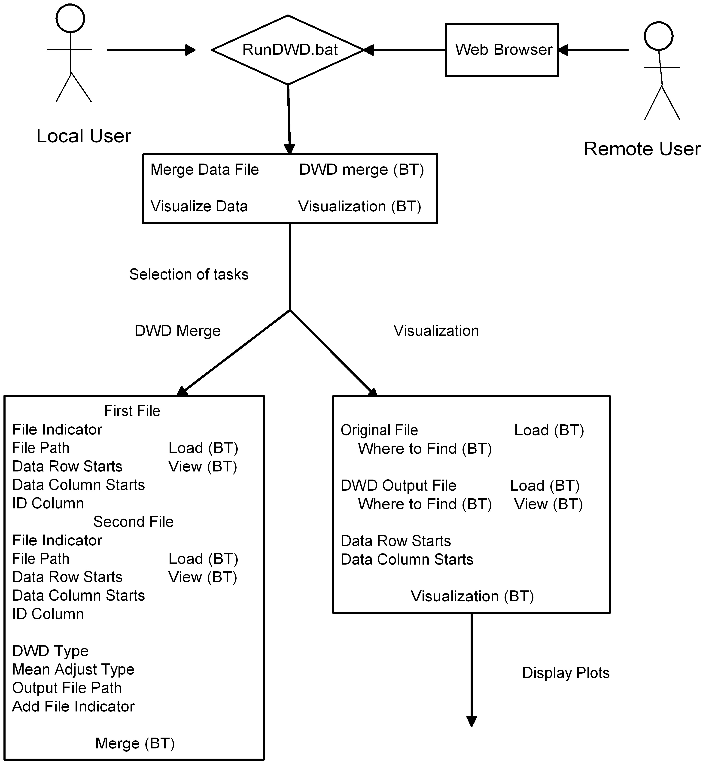
The relationships between the requirement categories described in Section 3, are illustrated in this process flow chart, which shows the logical function of the software. Rectangles represent menus visible to the user, and the text inside represents tasks, with (BT) representing buttons. Requirement Categories 1 and 2 refer to the top and lower left part of the chart. Requirement Category 3 is about the lower right part.

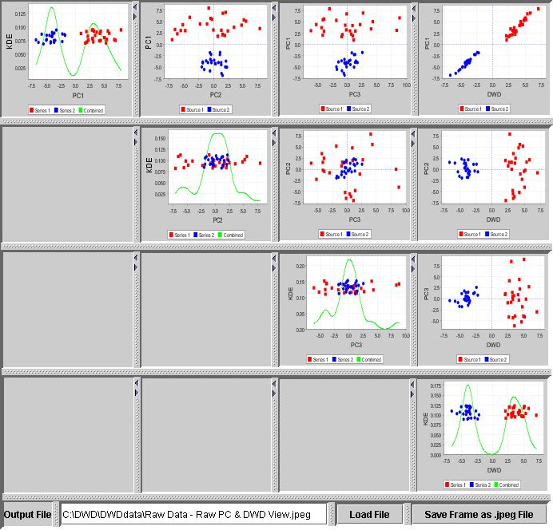

The main components, together with their interactions are illustrated in the following Architectural Diagram. The GUI is the main command and control module, and all data flows through it.
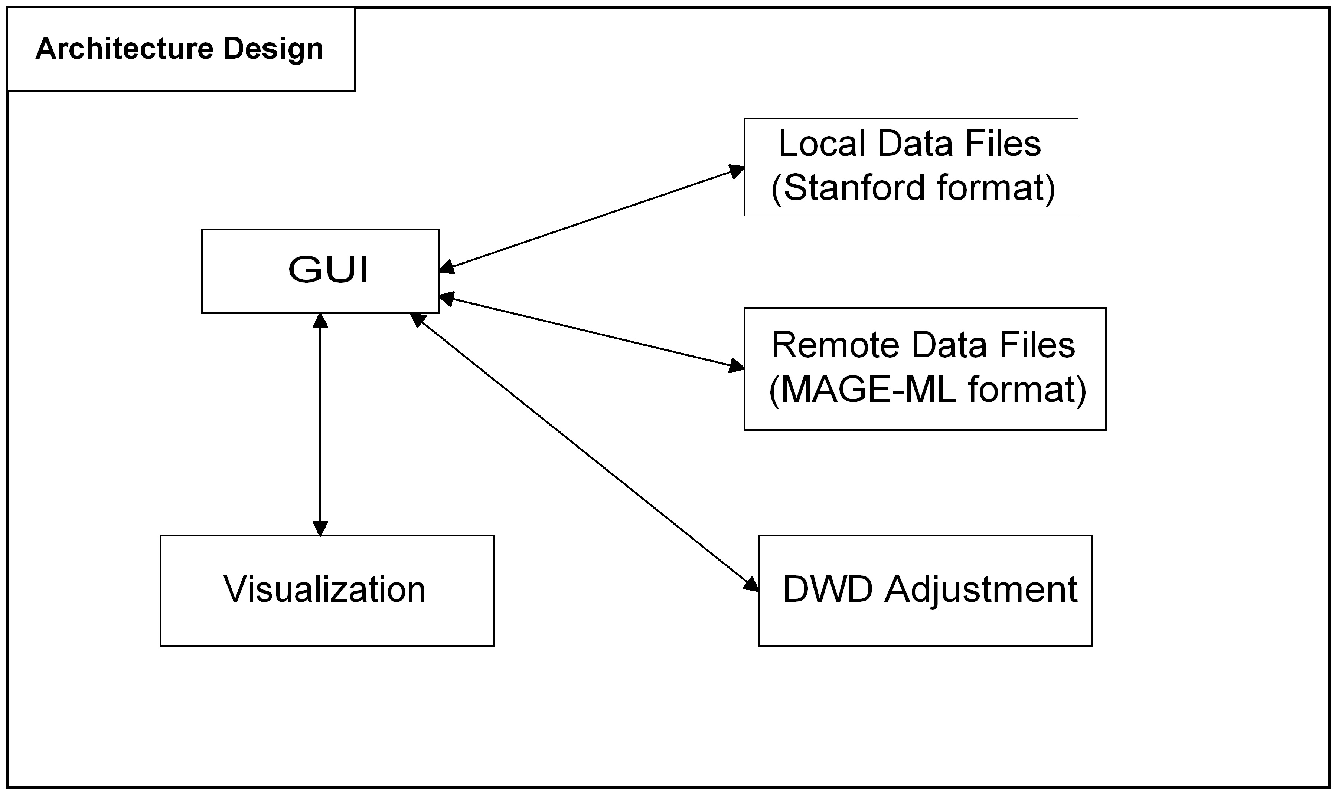

Illustration of the time sequence of events, and data transfers, are illustrated in this Sequence Diagram. The user initiates the merge process by pushing the DWD merge button on the GUI (after inputting appropriate parameter, such as name of dat filoes to be merged). The GUI requests the data from the file system. The GUI reqests the merge from the DWD Merging Module. The module gets the data file from the file system, and perfoms the merge. A “merge finished” message is sent back to the GUI, and the merged data file is stored. The user initiates the diagnostic visualization, by pushing the visualization button. The GUI send a request to the visualization module, which requests the data from the file system, performs the needed computations, and sends the graphics back to the GUI. The user can request that the graphics be saved on the file system.

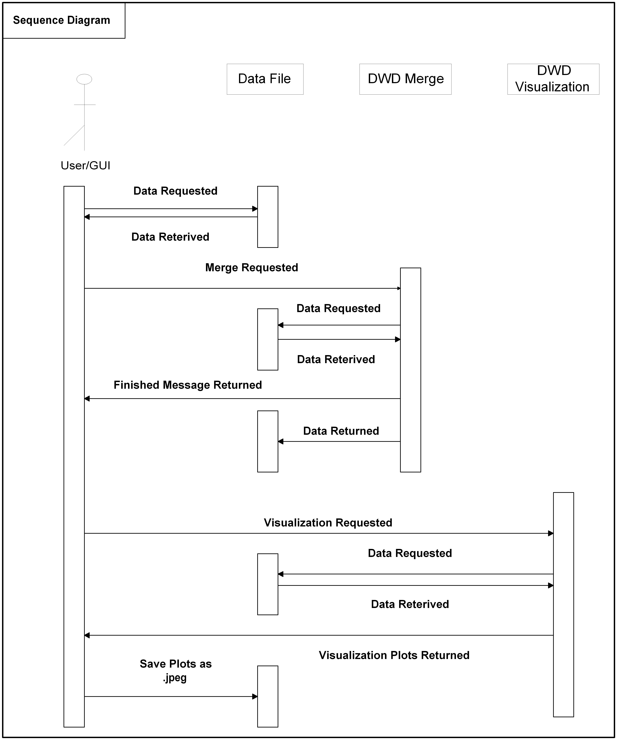

The external software interfaces are shown in the following Class Diagram Interfaces chart. This shows the three major classes, with their input and output.

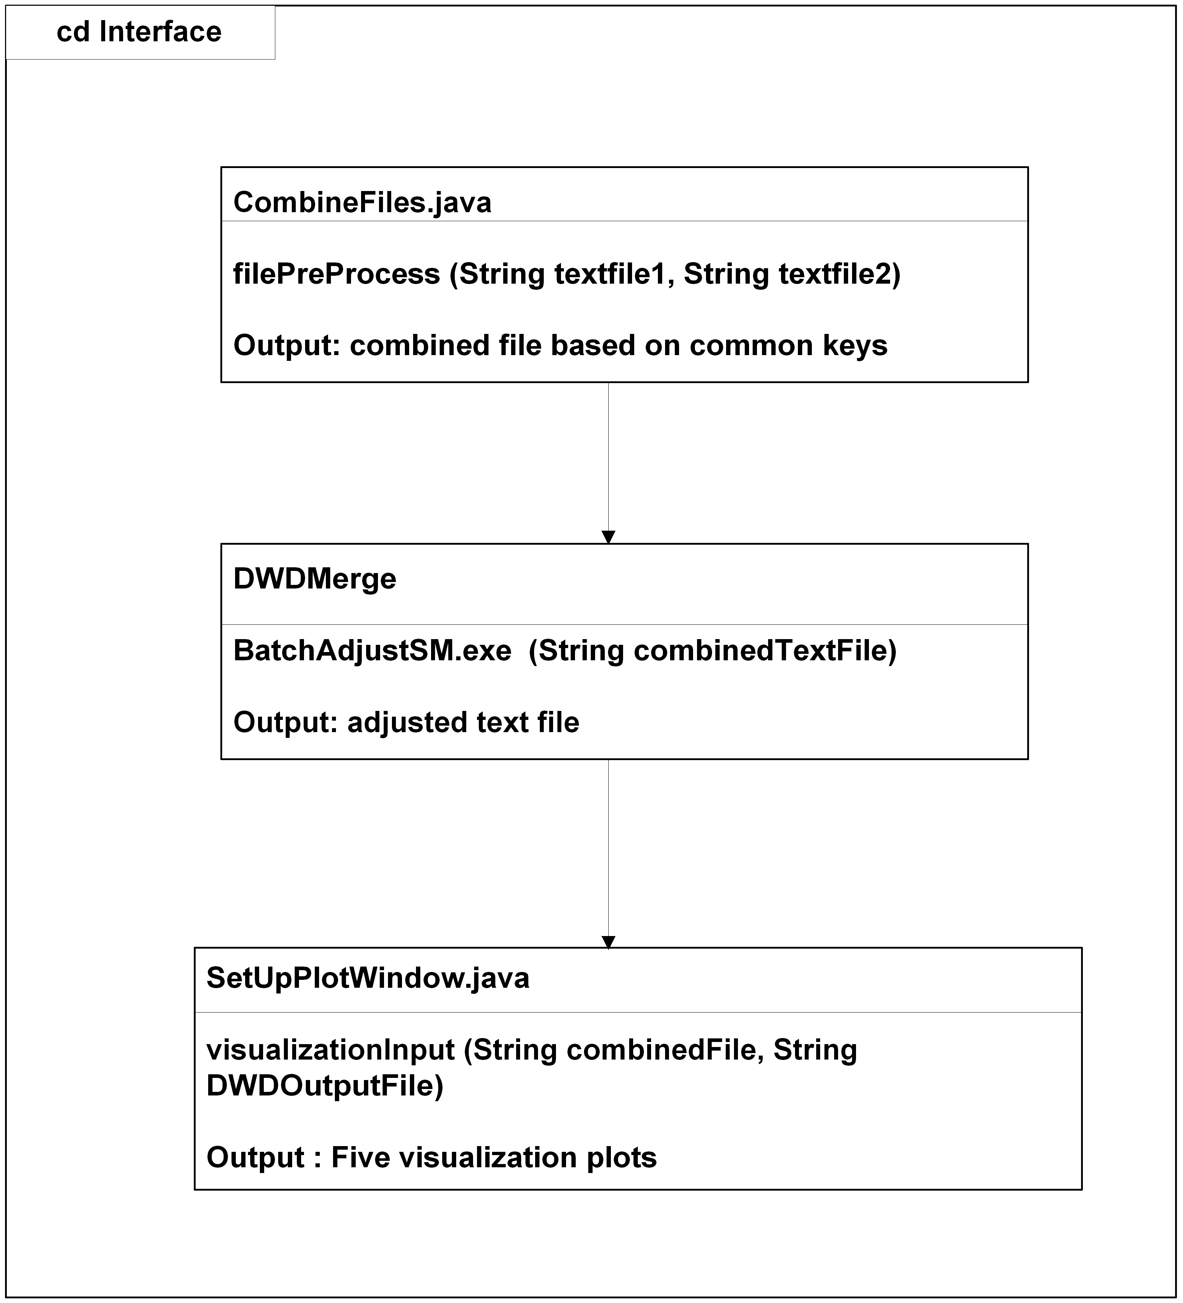

Components
As indicated in Section 3, there are four major components in the Java DWD software, the Java GUI for user interface, the DWD Adjustment Code (converted from Matlab), the Java Diagnostic Visualization, and the Web Service.

Java GUI
The Java GUI for DWD Adjustment has Requirement ID Numbers 1.1-1.11, in Section 3.
Type - This component is a stand alone Java program, which consists of eleven Java files.
Purpose – The purpose of this component is to provide the interface between the user and the code which does the adjustment. It allows the user to choose the input data files, and to assign a name to the output data file. The user may also choose several different auxiliary settings. The interface also reports progress of the adjustment, and gives messages indicating any errors that were encountered.
Function – The GUI consists of a control menu, with boxes for text entry, selection lists, and push buttons, together with a set of pop-up windows for tasks that include the indication of progress and errors.
The main control menu has the following text boxes:
- File Indicator of the first data set. Text, which will be used for each column in the output file, indicating which of the two data sets it came from (e.g. “1” or “2”).
- File Path (including file name) of the first data set.
- Data Row Starts at for the first data set (row number of the first row of the input data matrix with numerical expression values)
- Column Starts at for the first data set (column number of the first column of the input data matrix with numerical expression values)
- Identifier Column of the first data set (Column number for common ids of genes)
- File Indicator of the second data set.
- File Path of the second data set.
- Data Row Starts at for the second data set
- Column Starts at for the second data set
- Identifier Column of the second data set
- Output File Path (including file name)
The selection lists on the main menu are:
- DWD Type (2 choices)
  - DWD adjustment followed by column standardization (recommended for data from different platforms)
  - Straight DWD adjustment, with no additional normalization (typical for both data from the same platform)
- Mean Adjustment Type (3 choices)
  - Center both data sets at 0 (typical for differentially expressed data)
  - Centered at mean of first data set (leaves first data set unchanged)
  - Centered at mean of second data set (leaves second data set unchanged)
- Add File Indicator (2 choices)
  - Yes, adds row of text indicators, to allow tracking of which data came from which input file.
  - No, suppresses row of text indicators (useful when making repeated use of DWD in combining several data sets).
The push buttons on the main menu are:
- Load first Data File.
- Load second Data File.
- View first Data File.
- View second Data File.
- Save Output File To
- DWD Merge

Clicking on the DWD Merge button causes the execution of:
- Preprocess the input files, for input to the c executable (in the next component). This involves combining the two input files based on common gene identifiers (with non-common gene identifiers ignored, for arbitrary gene ordering of the input files.
- During the preprocessing of input files, the missing data will be checked. The presence of missing data generates an error message, reporting the row number of each missing value, and execution stops.
- Call the second component (c executable) which does the DWD data adjustment.
- Post process the results generated by the second component by adding the gene identifier column back to the data matrix. Column standardization is also done when requested.

Progress of these steps is relayed to the user by the GUI, using pop-up windows. These are:
- Progress Indicator Window. Shows that the program is running. This is replaced when the program is finished.
- Error Message Window. Indicates various types of errors:
  - Missing values in input data.
  - Non-numerical value encountered in gene expression field.
  - No common gene identifiers.
- Program Finished Window. This replaces the Program Indicator, when the merge of the data is complete.

Subordinate – This component has no children.
Dependencies – There are 2 major dependencies of this software:
- The two input data files currently must be in Stanford text format on the local machine (and eventually MAGE-ML from caARRAY will also be allowed). More than two data sets are currently handled by pair-wise merging.
- The two input files must have common gene identifiers.
Precondition – There can be no missing data. If missing data are found, a pop-up message will indicate this error, and execution will terminate. Missing data can be handled by imputation, as indicated in 2.4.
Interfaces – Input data consists of two data files (currently in Stanford text, later in MAGE-ML), of micro-array data, with common gene identifiers. Output is a single merged data file (currently Stanford text, later MAGE-ML), with merged gene expression values, and all other data elements preserved.
Graphics - This component has only the GUI for the Main Control Menu, and the pop-up windows indicated above. A screen shot of the Main Control Menu is provided below:

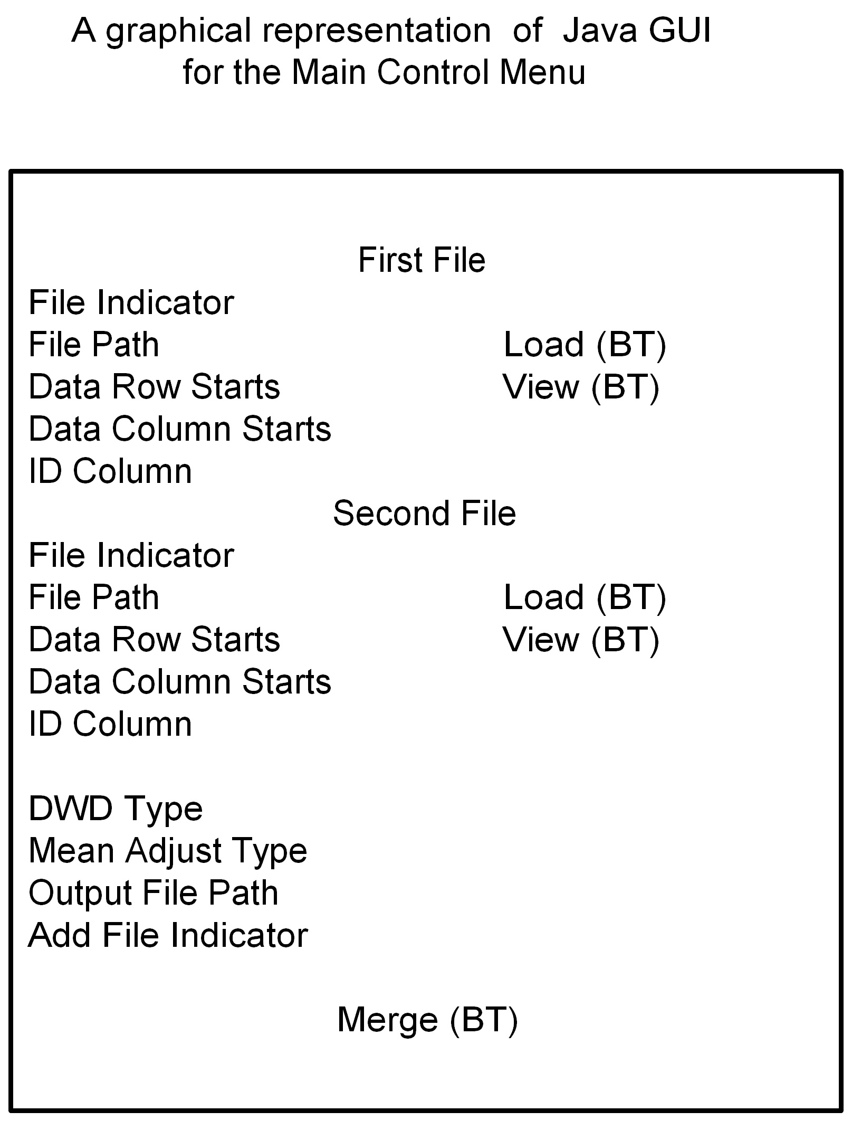

Resources – Standard PC interface, with monitor for display to user, plus keyboard and mouse for entering text and pushing buttons are needed.
References – References for auxiliary material for this component are given in Section 1.2.
Processing – Pseudo code for describing the control and data flow are shown below.
Set up the frame which shows all text boxes, buttons and list selections
Retrieve all input values of parameters
While reading in two input files
Check the missing data
while there are common IDs in the two input files
Combine into one file
Call the second component to do adjustment
Output the adjusted data and DWD vector as two text files
While reading in the results generated by the second component
Put back the keys and save results to the output file

Data – The main component of the data is a matrix of numerical gene expression levels, where rows of the matrix correspond to genes, and columns correspond to samples (i.e. cases). These can be either positive and negative (for differential expression platforms such as cDNA), or non-negative, for absolute expression values (e.g. Affymetrix and other single channel systems).
In addition lists (perhaps several) of gene names are included, and also lists (again perhaps several) of case identifiers, as well as perhaps values of clinical covariates. These auxiliary lists are included as additional rows and columns of text fields in Stanford text format, and as objects in the MIAME standard that underlies MAGE-ML.
Space Estimates - The software itself requires approximately 8 Mb of disk space.
During execution, there must be at least enough RAM available to hold both data sets, together with the merged data simultaneously. For the merging of currently considered data sets (number of arrays around 100, number of genes around 10 to 20 thousand), 128 Mb is adequate.
System security – This is not an issue for this component, because it only uses data that are currently available to the user, and only gives the result back to the user.

DWD Adjustment
The Matlab Conversion component has Requirement ID Numbers 2.1-2.5, in Section 3.
Type - A c executable file converted from forty Matlab files and 26 libraries.
Purpose – This file does the main numerical work in DWD adjustment of the data.
Function – The main steps in the adjustment operation are:
- Read in the input data file that was generated by the Java GUI in the first component.
- Find the DWD direction vector, using the Second Order Cone Programming Algorithm, implemented in SDPT3,
- Shift the data classes along the vector, using the projected class means, as specified by the Mean Adjustment Type option.
- Output the DWD adjusted data set, and the DWD direction vector.
Subordinate – This component has no children.
Dependencies – This component is called by, and receives data, and options, from the Java GUI. It has twenty six libraries, which only work under the Windows OS.
Precondition – The only preconditions are those listed for the Java GUI Component above.
Interfaces – Input data is a single data file, where the first row indicates the original source of the input files, and the remaining rows contain microarray expression data from the two data sets being combined. Also input is a file containing the value of the Mean Adjustment Type parameter. Output is a single data file, where the first row continues to index original source, and the remaining rows are the adjusted expression values.
Graphics – This component has no graphics.
Resources – Standard PC CPU only is needed for the component.
References – References for auxiliary material for this component are given in Section 1.2.
Call BatchAdjustSM.exe
While read-in data is available,
Matrix[i,j] = read-in value
Find DWD direction vector
Read in parameter value of Mean Adjustment Type
Shift data in direction of DWD direction, according to Mean Adjustment Type
Output adjusted data
Output DWD direction vector.

Data – The main component of the data is a matrix of numerical gene expression levels, where rows of the matrix correspond to genes, and columns correspond to samples (i.e. cases). These can be either positive and negative (for differential expression platforms such as cDNA), or non-negative, for absolute expression values (e.g. Affymetrix and other single channel systems).
In addition there is a single first row, containing the original input source identifiers.
Space Estimates - The software itself requires approximately 8 Mb of disk space.
During execution, there must be at least enough RAM available to hold both data sets, together with the merged data simultaneously. For the merging of currently considered data sets (number of arrays around 100, number of genes around 10 to 20 thousand), 128 Mb is adequate.
System security – This is not an issue for this component, because it only uses data that are currently available to the user, and only gives the result back to the user.

Java Visualization
The Java GUI for Visualization is assigned ID Numbers 3.1-3.5, in Section 3.
Type - This component is a stand alone Java program and a c executable. The Java program consists of seven Java files. The c executable file is converted from forty six Matlab files.
Purpose – The purpose of this component is to provide visual diagnostics, which indicates how successful the DWD data merge has been. The first part is an interface between the user and the code which does the visualization. The interface allows the user to choose the input data files, and to assign a name to the output image file. The interface also reports progress of the plotting of the data, and gives messages indicating any errors that were encountered. The resulting graphics are displayed on the monitor.
Function – The GUI consists of a control menu, with boxes for text entry, and push buttons, together with a set of pop-up windows for tasks that include the indication of progress and errors.
The main control menu has the following text boxes:
- Original File.
- DWD Output File.
- Data Row Starts at for DWD Output File
- Column Starts at for DWD Output File
The push buttons on the main menu are:
- Load Original File
- Load DWD Output File
- View DWD Output File
- Where To Find the Original File
- Where To Find the DWD Output File
- Visualization

Clicking on the Visualization button causes the execution of:
- Set up a graphics frame and enter the parameters for the original file and the adjusted data file;
- Compute the principal component analysis;
- Compute the Kernel density estimates;
- Display all the plots;
- Save all plots as jpeg files.

Progress of these steps is relayed to the user by the GUI, using pop-up windows. These are:
- Progress Indicator Window, which shows that the progress is running. This is replaced when the program is finished.
- Error Message Window. Indicates various types of errors, such as common genes less than four.
- Program Finished Window. This replaces the Program Indicator, when the graphics generation is complete.

Subordinate – This component has five children, which are five different graphic windows.
Dependencies – No.
Precondition – The data have been successfully merged by DWD (thus there are no missings).
Interfaces – Input data consists of two data files which are generated by DWD adjustment (first and second components ).
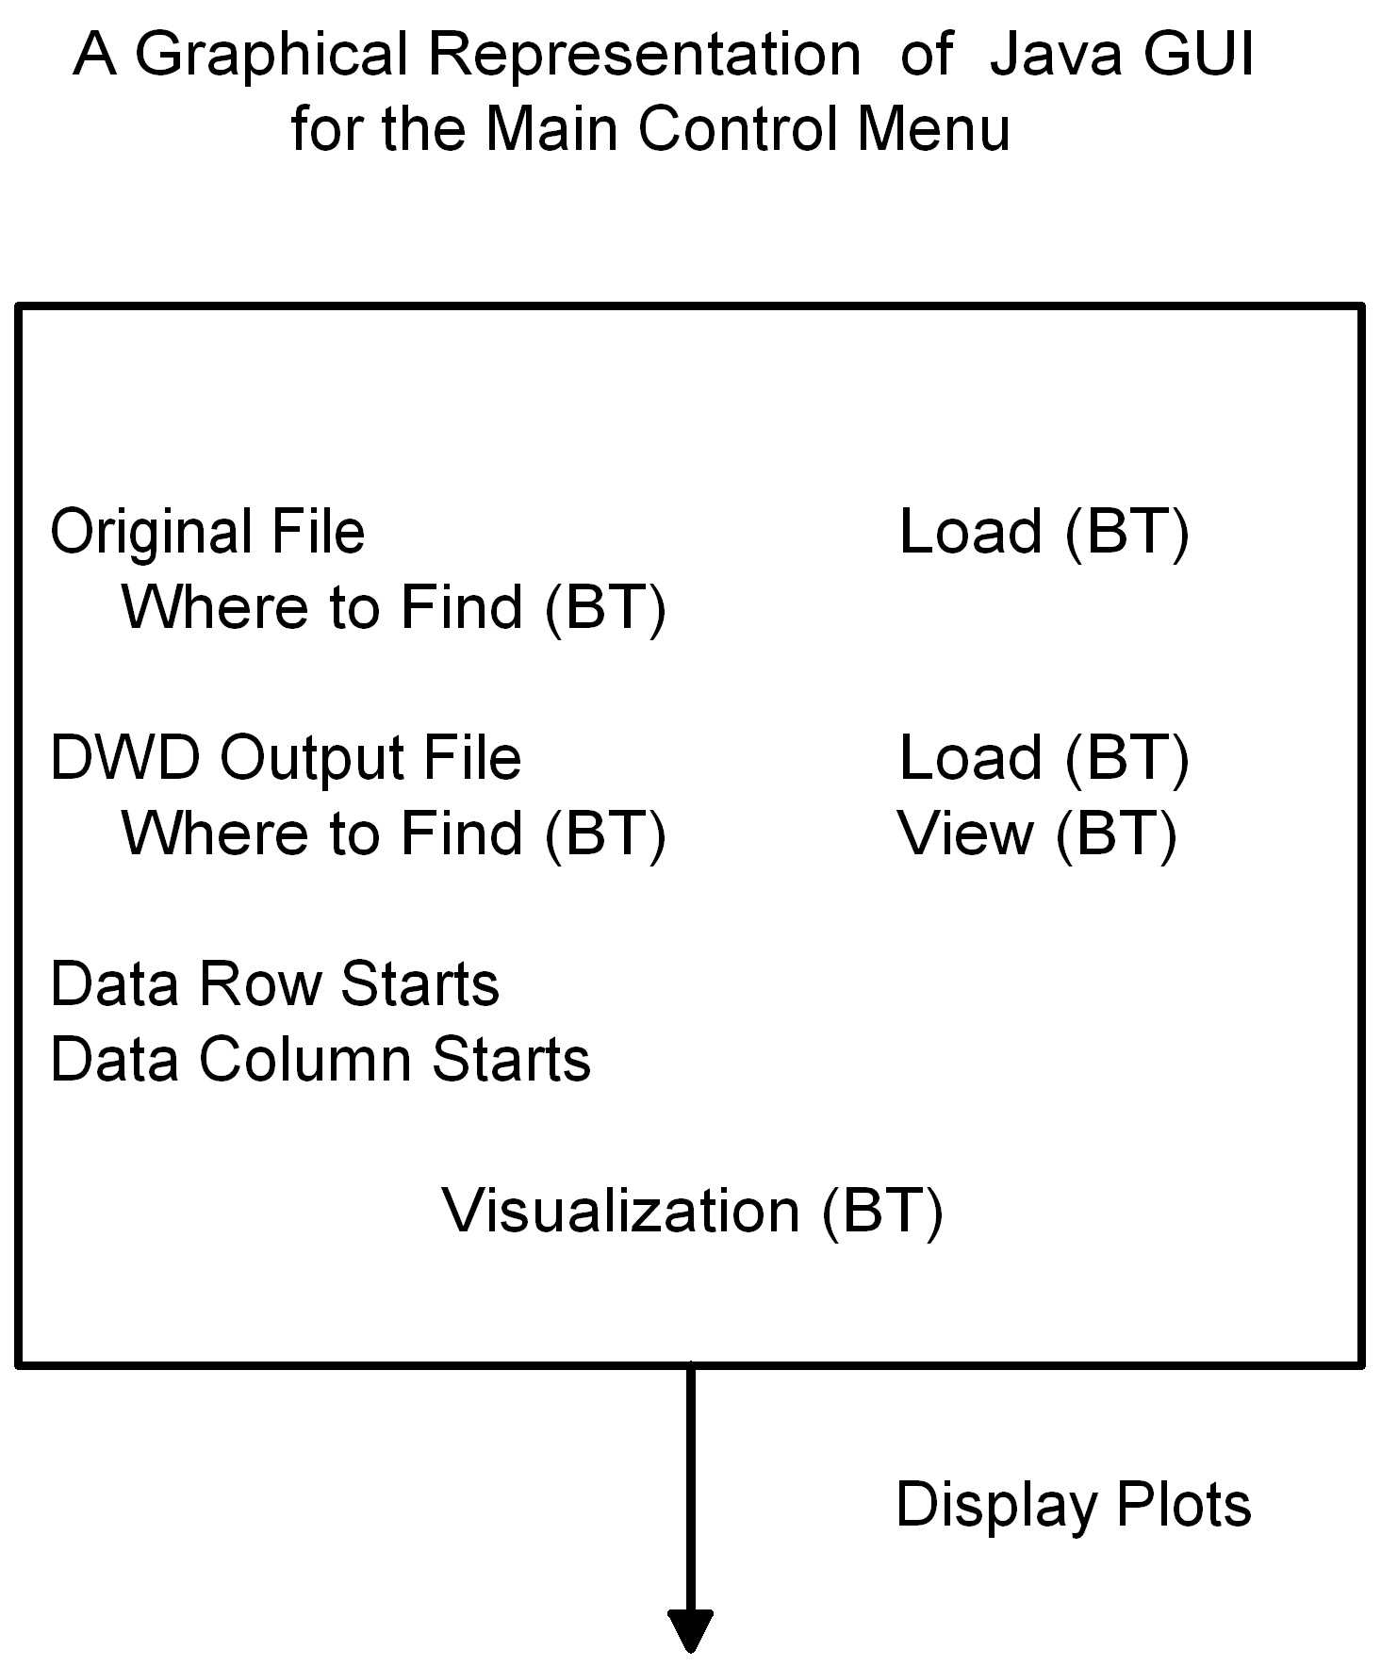
Graphics - This component has only the GUI for the Main Control Menu, and the pop-up windows indicated above. A graphical representation of the Main Control Menu is provided below:

Resources – Standard PC interface, with monitor for display to user, plus keyboard and mouse for entering text and pushing buttons are needed.
References – References for auxiliary material for this component are given in Section 1.2.
Processing – Pseudo code for describing the control and data flow are shown below.
Set up the frame which shows all text boxes and buttons
Retrieve all input values of parameters
While reading in the two input files
Report errors in the input files
Compute PCA and KDE
Set up frame for each visualization
Display plots in five separate graphic windows, for:
Raw Data, Raw PC, i.e. PC directions chosen using raw data
Raw Data, Raw PC + DWD, i.e. 4th PC direction is replaced by the DWD direction.
Adjusted Data, Raw PC + DWD,
Adjusted Data, Raw PC.
Adjusted Data, Adjusted PCA, i.e. with PCA directions for adjusted data.
Save each window into a jpeg file.

Data – The raw data file here is the combination of the two input files, with common genes, which is created prior to DWD adjustment. The first row of this file indicates the origin of the two input files, to allow assignment of different colors.
The DWD output file generated by DWD adjustment currently is still in Stanford Text Format.
Space Estimates - The software itself requires approximately 8 Mb of disk space.
During execution, there must be at least enough RAM available to hold both data sets, together with the merged data simultaneously. For the merging of currently considered data sets (number of arrays around 100, number of genes around 5 to 20 thousand), 128 Mb is adequate.
System security – This is not an issue for this component, because it only uses data that are currently available to the user, and only gives the result back to the user.

Web Service
The Web Service version of Java DWD is assigned ID Numbers 4.1-4.4, in Section 3.
Type – This is an HTML file, with a Java Script, Java Servlet, which calls the Java DWD GUI
Purpose – The purpose of this component is to provide web accessibility to users, for running DWD on a UNC server.
Function – The web server version of DWD calls the GUI version, and thus provides the same user interface. As noted above, this consists of a control menu, with boxes for text entry, and push buttons, together with a set of pop-up windows for tasks that include the indication of progress and errors.
Subordinate – This component has one child, the DWD GUI.
Dependencies – No.
Precondition – Internet access must be available.
Interfaces – The user first uploads data to the DWD Server. After DWD runs, a link is given so that the user can download the result.
Graphics - This component has only the web page GUI. A graphical representation of the Web Page GUI is provided below:
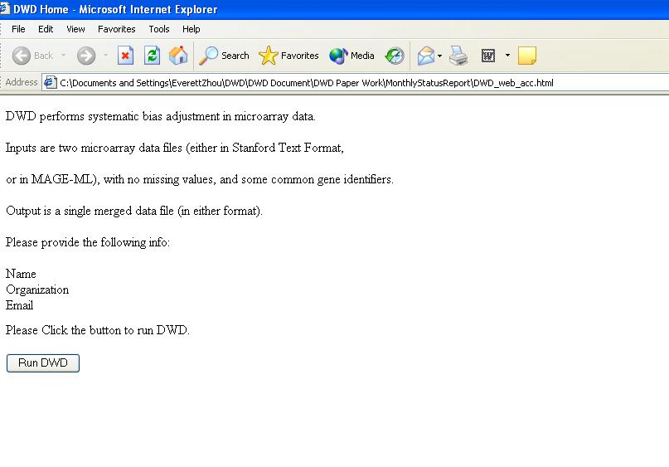

Resources – User needs only a Standard PC, with monitor for display to user, plus keyboard and mouse for entering text and pushing buttons are needed. The UNC DWD project needs a Windows server.
References – References for auxiliary material for this component are given in Section 1.2.
Processing – Pseudo code for describing the control and data flow are shown below.
Open the browser, and to the DWD website.
Enter use profile (into text box).
Upload two input files
Run Standalone DWD
Data communication: Download combined data file, and visualizations
Data – The raw data file is the same as for component 1.
Space Estimates - The UNC server will have approximately 3.00 GHz speed and 2G of RAM.
System security – The server will be configured according to the UNC Security Standard.

Sign off

Approval

Louise C. Showe 6/27/05
Adopter Representative, Louise Showe, The Wistar Institute Date

Appendix A – Acronym List

Term/  Abbreviation | Description
DWD | Distance Weighted Discrimination
SDPT3 | Semi-Definite Programming Package
GNU GPL | GNU's not Unix, General Public License
DBA | Database Administrator
PM | Project Manager
RM | Requirements Manager
RTM | Requirements Traceability Matrix
SCM | Software Configuration Management
SDLC | Software Development Lifecycle
SDP | Software Development Plan
SE | Software Engineering
SEPG | Software Engineering Process Group
SM | Software Manager
SOP | Standard Operating Procedure
SPI | Software Process Improvement
SQA | Software Quality Assurance
SW | Software
TBD | To Be Determined
TM | Test Manager

